Client Mobile App

1.Client Mobile App – Overview
2.Voter Search
3.Advanced Search & Filtering
4.Voter Profile & Actions
5.Voter Classification
6.Survey Module
7.Language Support
8.Analysis & Reports
9.Voter Slips & Documentation

Election Management Software
Functional & System Documentation

1. Introduction
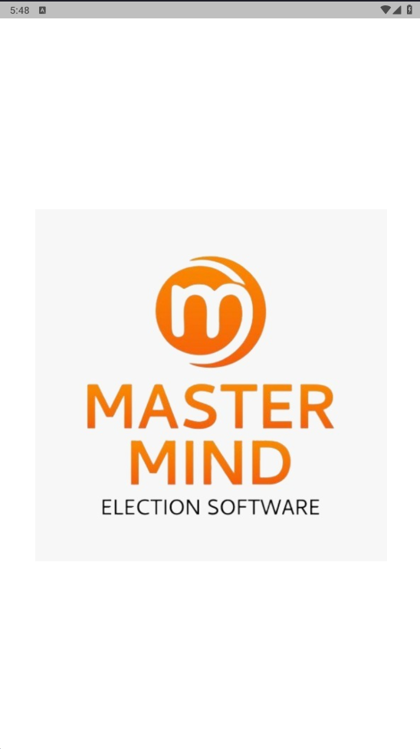
Election Management Software is a voter data management and campaign support application developed to help election candidates and their teams manage voter information in an organized, efficient, and practical way.
The software focuses on requirements such as voter search, booth-wise management, surveys, voter classification, and data analysis. It is designed to reduce manual work, avoid data confusion, and help campaigns make decisions based on actual voter data instead of assumptions.
The system is available on Android, iOS, allowing users to access and manage campaign data from anywhere.
2. Purpose of the System
The main purpose of this application is to:
- Centralize voter data in one system
- Make voter information easy to search and update
- Support survey collection and voter feedback
- Help identify supporters, opponents, and undecided voters
- Provide clear reports and analysis for campaign planning
This software is intended for use during Lok Sabha, Vidhan Sabha, Municipal, Nagar Parishad, and Panchayat elections.

3. System Access & Login
Access to the application is controlled through an Activation Key.
Login requires:
- Activation Key
- User Name
- Contact Number
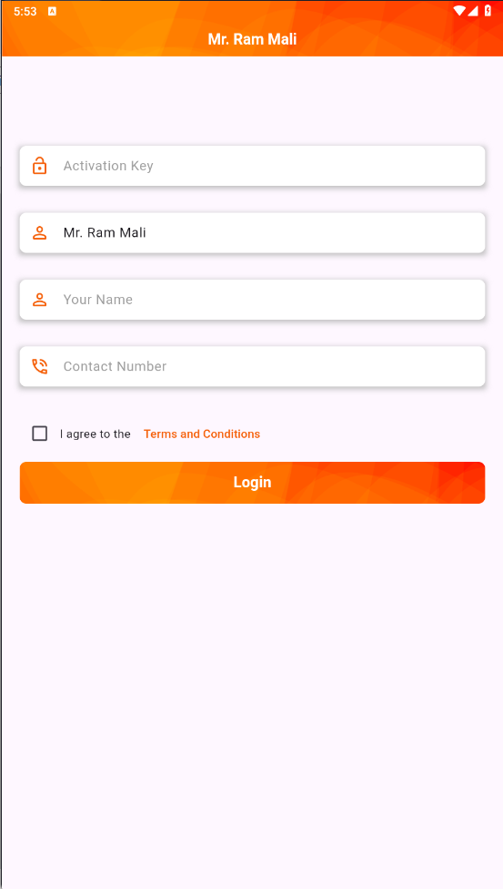
- Acceptance of Terms & Conditions
Once activated, the same credentials can be used across mobile and web platforms. This ensures controlled access and prevents unauthorized usage.

4. Home Screen & Navigation
After login, the user is presented with a dashboard that provides access to the following main sections:
- Voter Search
- Advanced Search
- List / Booth-wise Data
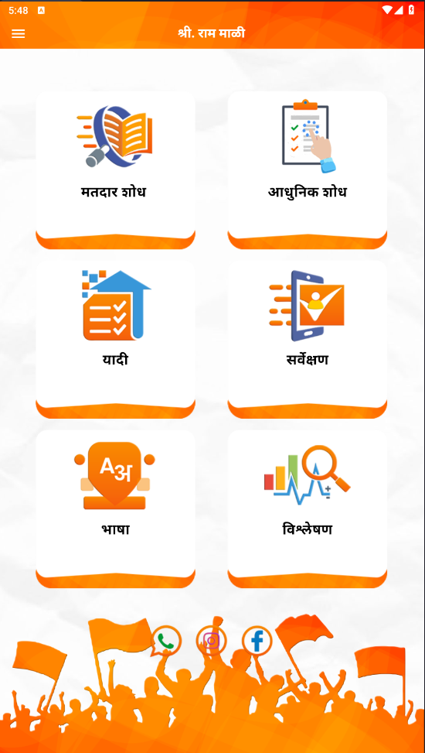
- Survey
- Language Selection
- Analysis & Reports
Navigation is icon-based and kept simple so that even field workers with minimal technical knowledge can use it comfortably.

5. Voter Search Module
5.1 Normal Search
The normal search allows users to find voters by:
- Full name
- Partial name (3–4 characters)
- Surname-based search
This is useful when the full name is not known. The system quickly displays matching voter records.

6. Voter Profile Details
Clicking on any voter opens a detailed voter profile.
Information available includes:
Personal Information
- Full name
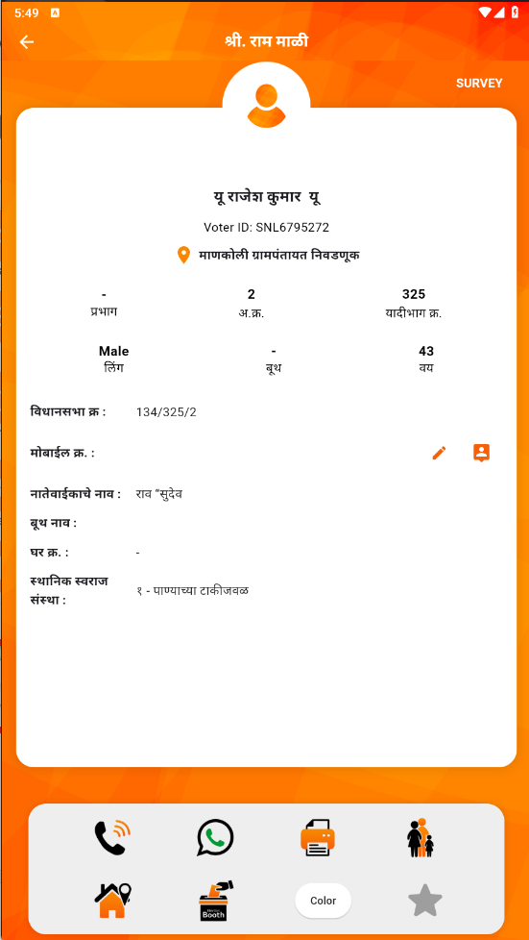
- Gender
- Age / Date of birth
- Mobile number
- Email ID
- Voter ID

Address & Location
- House number
- Full address
- Booth name
- Ward number
- Area / Division
- Polling center details
All voter-related actions are accessible from this screen.

7. Voter Actions & Utilities
From the voter profile, the user can perform the following actions:
- Call the voter directly
- Send WhatsApp messages or images
- Print voter slip / polling chit
- View family members linked to the same address
- Mark voter as important using a star
- Assign voter category using color codes
These actions help campaign workers interact with voters quickly and keep records updated.

8. Voter Classification (Color Coding)
Voters can be classified into categories using colors, such as:
- Supporter
- Opponent
- Doubtful
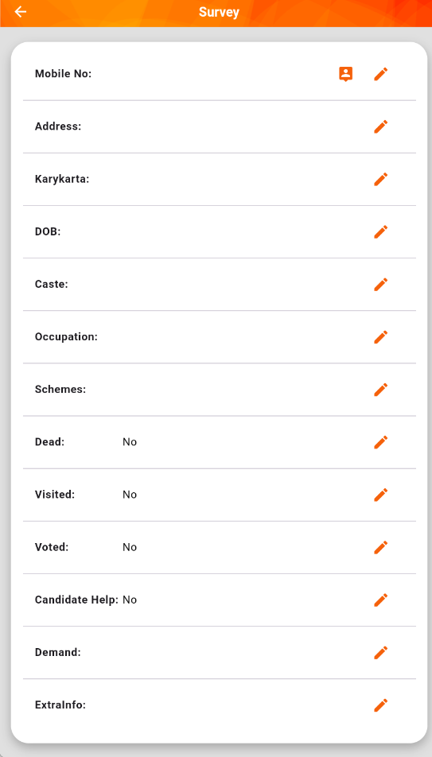
- Neutral / Other
This classification helps the campaign team understand voter alignment and focus efforts where required.

9. Survey Module
9.1 Individual Survey
The survey module allows detailed data collection for each voter, including:
- Caste
- Occupation
- Scheme benefits
- Whether the voter voted or not
- Whether a visit was made
- Help requested by voter
- Any additional remarks
This data is crucial for ground-level campaign planning.
9.2 Bulk Survey
Bulk survey functionality allows survey data to be entered for multiple voters at once.
This is especially useful for large-scale field operations handled by campaign workers.

10. Filtering & Sorting
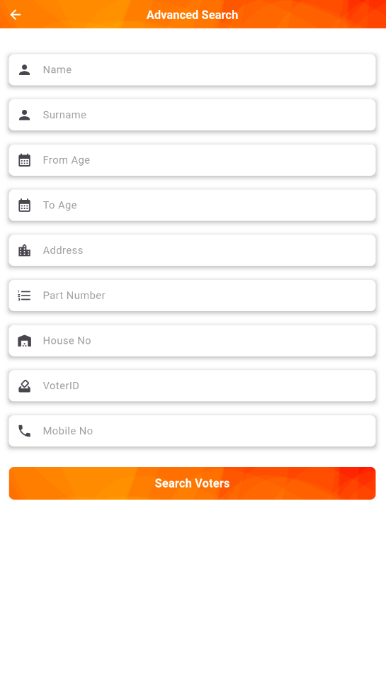
The system provides strong filtering options to organize voter data based on:
- Age range
- Gender
- Ward / Booth
- Caste
- Occupation
- Scheme beneficiary status
- Vote status
- Mobile number availability
- Duplicate voting indicators
Filtered data can be reviewed on screen or exported.
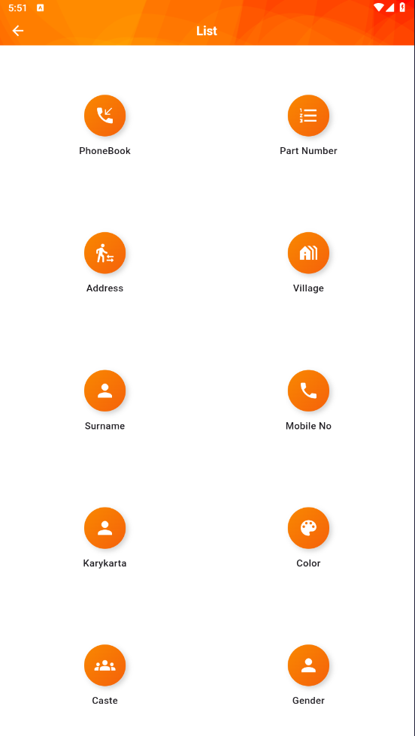

11. Language Support
The application supports multiple languages:
- Marathi
- Hindi
- English
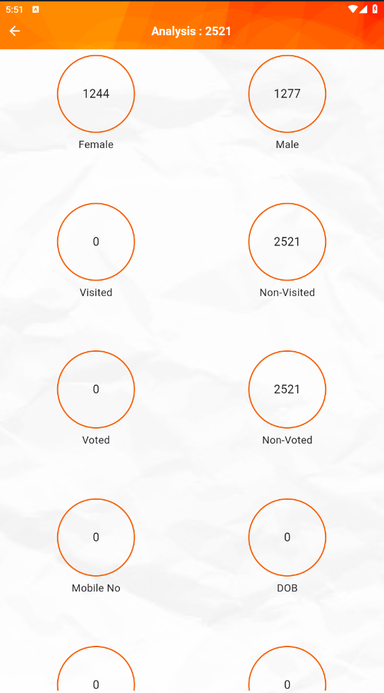
Users can switch languages at any time, which makes the app practical for local field teams.

12. Analysis & Reports
The analysis section provides summarized insights such as:
- Total male and female voters
- Important voters
- Voters visited vs not visited
- Votes given vs not given
- Mobile number availability
- Date of Birth wise list
Reports can be:
- Viewed inside the app
- Downloaded as PDF
- Downloaded as Excel files
These reports are useful for review meetings and planning sessions.

13. Voter Slips & Documentation
The system allows:
- One-click voter slip generation
- Booth-wise voter lists
- Family-wise voter reports
- Printable polling documents
This reduces dependency on manual registers and printed voter lists.

14. Practical Benefits
- Saves time during voter lookup
- Improves Tracking and organization of voter
- Enables data-based decision making
- Works from mobile or desktop

15. Conclusion
Election Management Software acts as a central operational tool for election campaigns.
By combining voter data, surveys, classification, and analysis in one system, it helps campaigns work in a structured and efficient manner rather than relying on scattered records or guesswork.

